**Elastic File System**

Mount Elastic File System (EFS) on EC2

Amazon EFS is a fully managed, scalable file storage service designed to provide shared access to files across multiple Amazon EC2 instances. It is particularly useful for applications and workloads that require shared file storage in a cloud environment.

Steps for EFS

1. Create security group
2. Create EFS
3. Create instances(ec2) in howmany availability zones u need to share the file.
4. We sharing the file in 3 availability zones.so we need to create 1 instances in each availability zone

CREATING THE SECURITY GROUP.(SG-Efs)

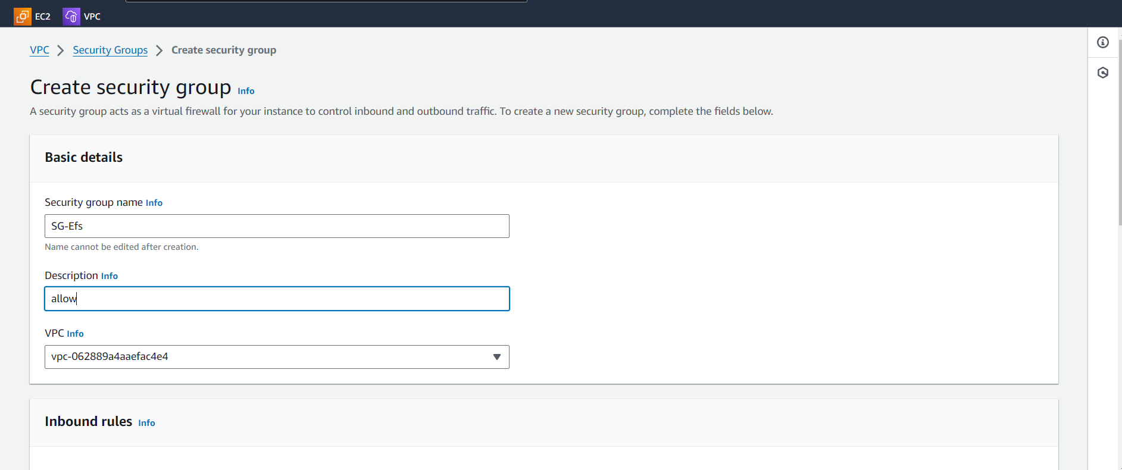

Attaching the all traffic and SSH in the inbound rules and click on the save changes.

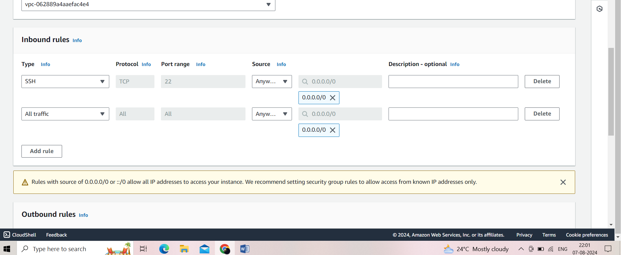

Security group is created

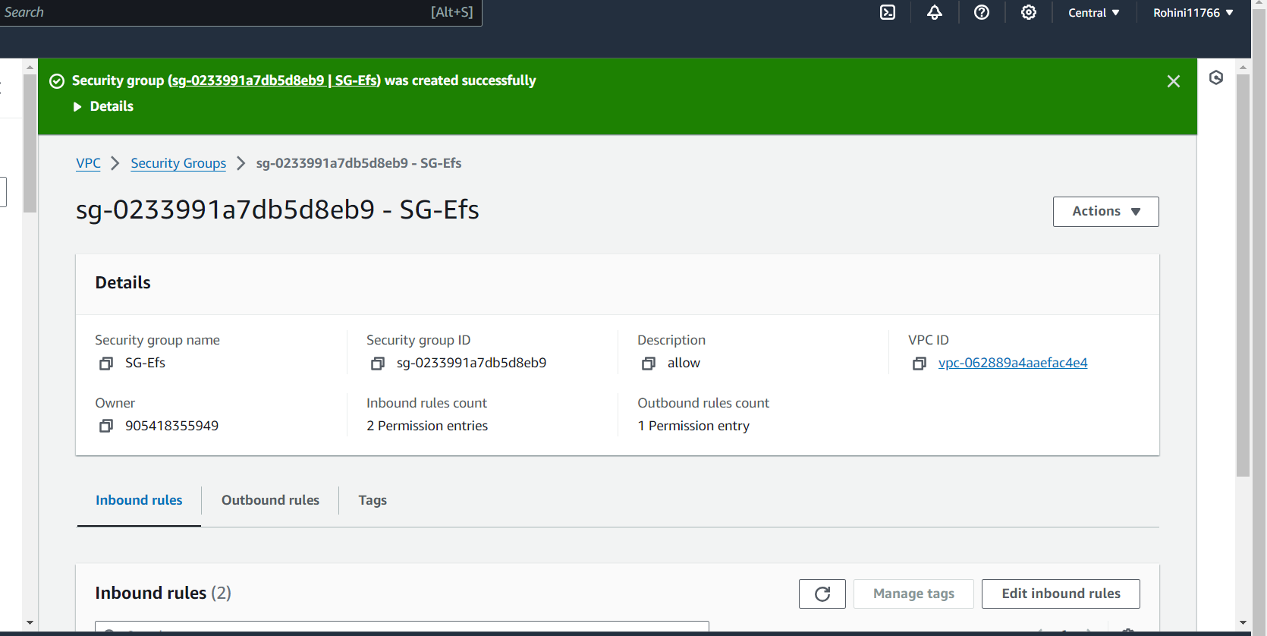

Creating the EFS

Click on create Efs

Name given as task

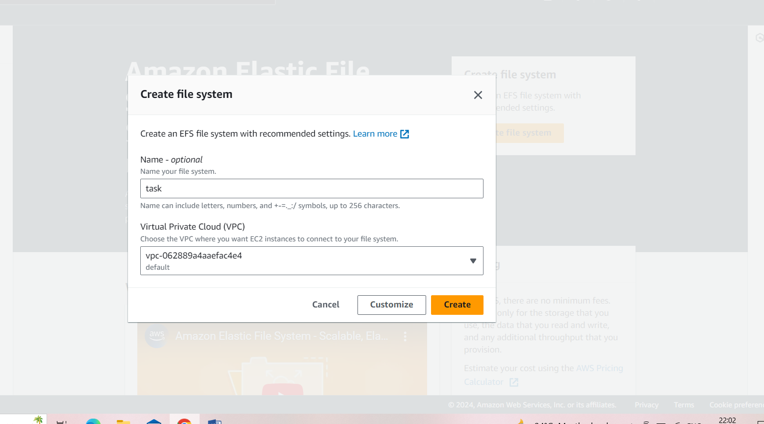

Click on customize

Select regional 🡪. Next 🡪 next 🡪select the security group created already🡪next🡪create

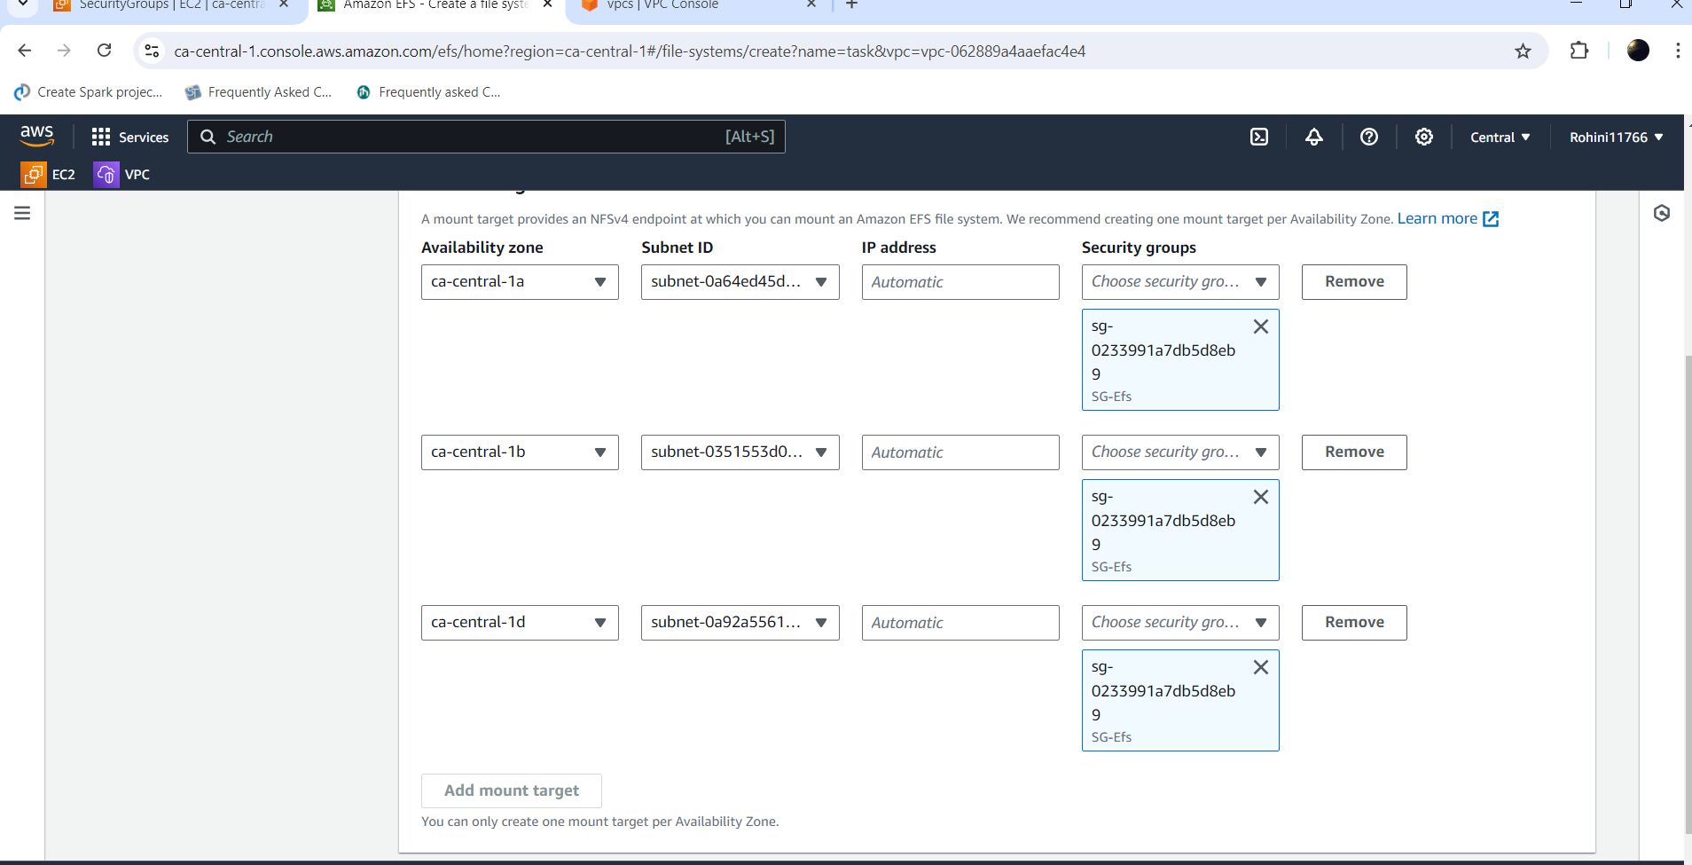

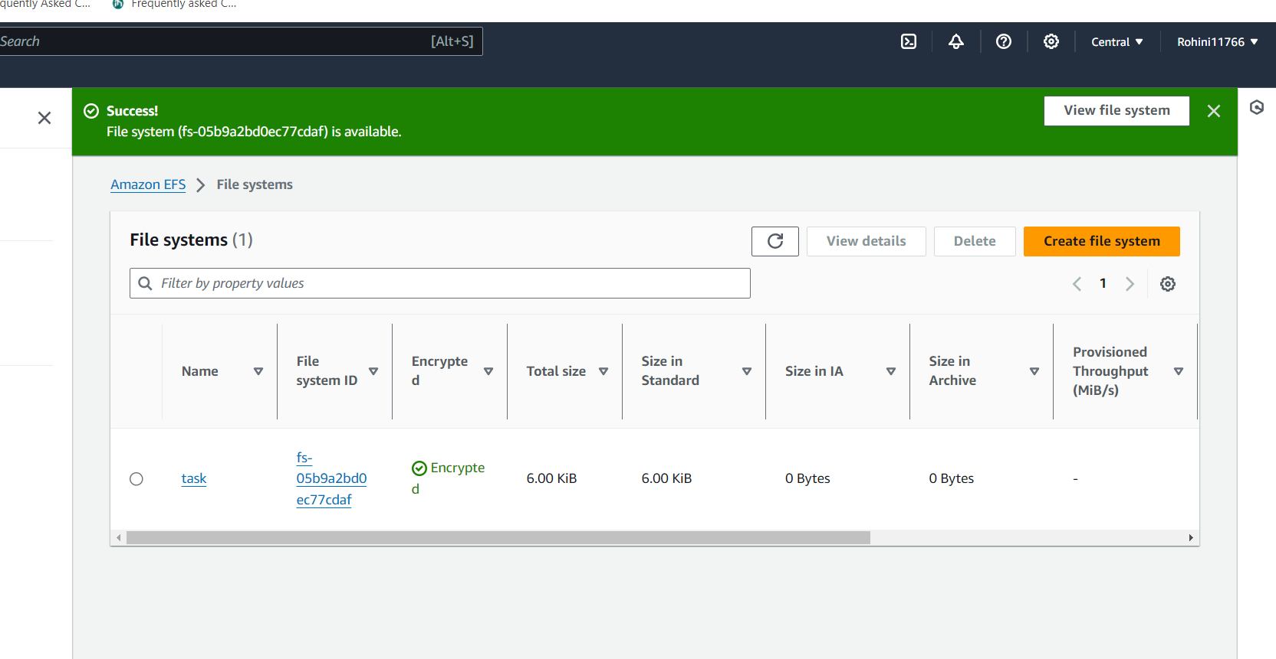

The EFS is created

Now launching the instance with the name ec1

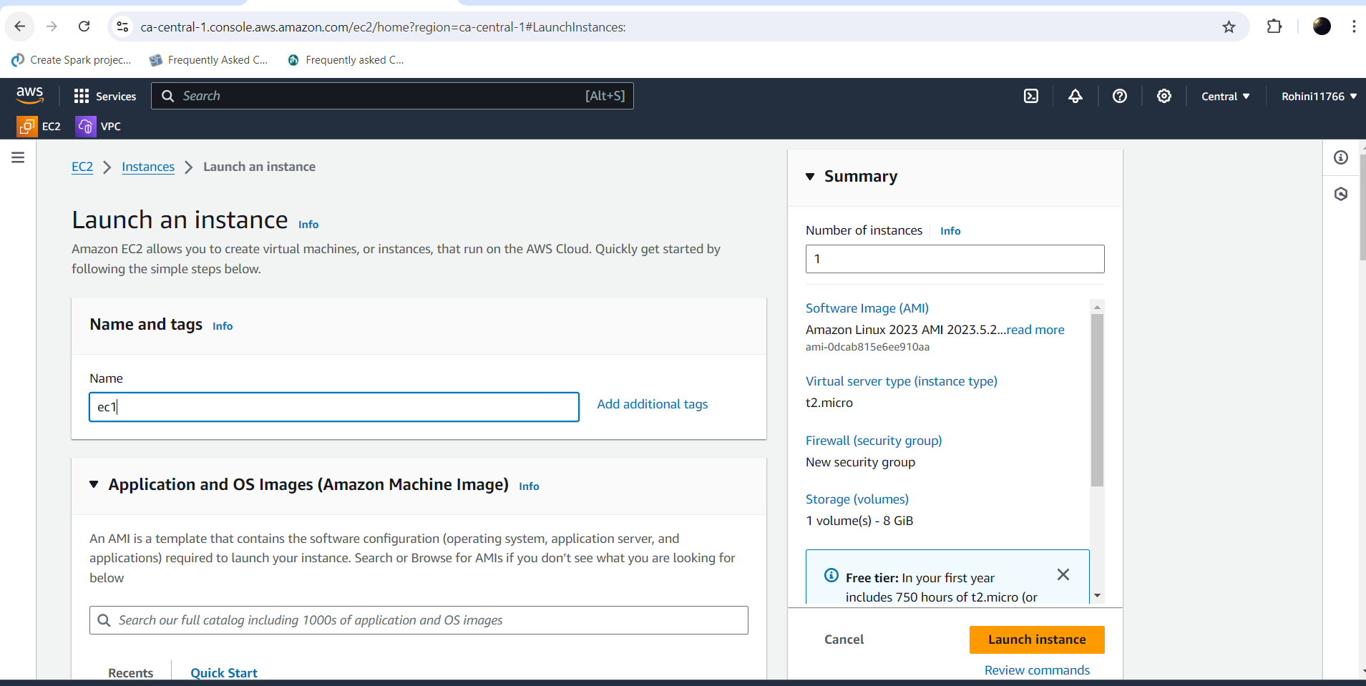

Select t2 micro give the keypair

Click on edit(networks)

Give the default vpc

Sleetc the existing security grp

Selecting the subnet as ca –central-1a

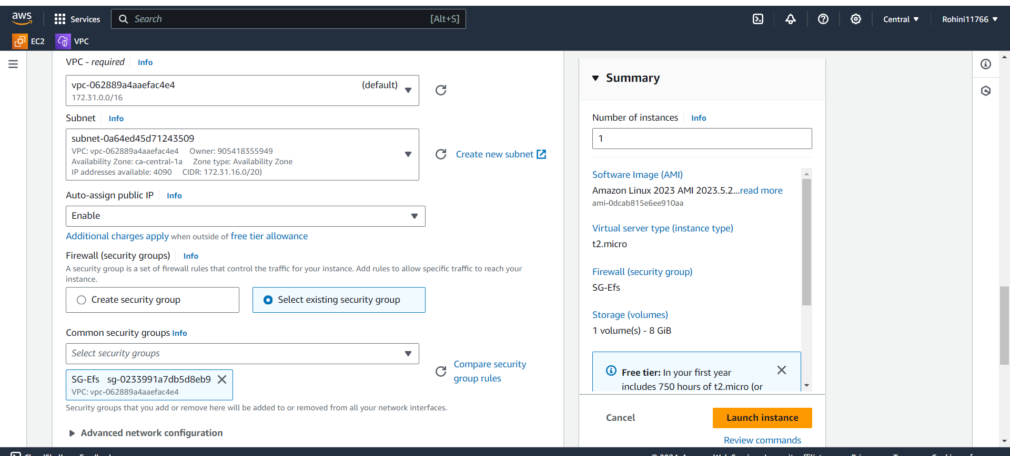

Click on file system and select the add shared file system

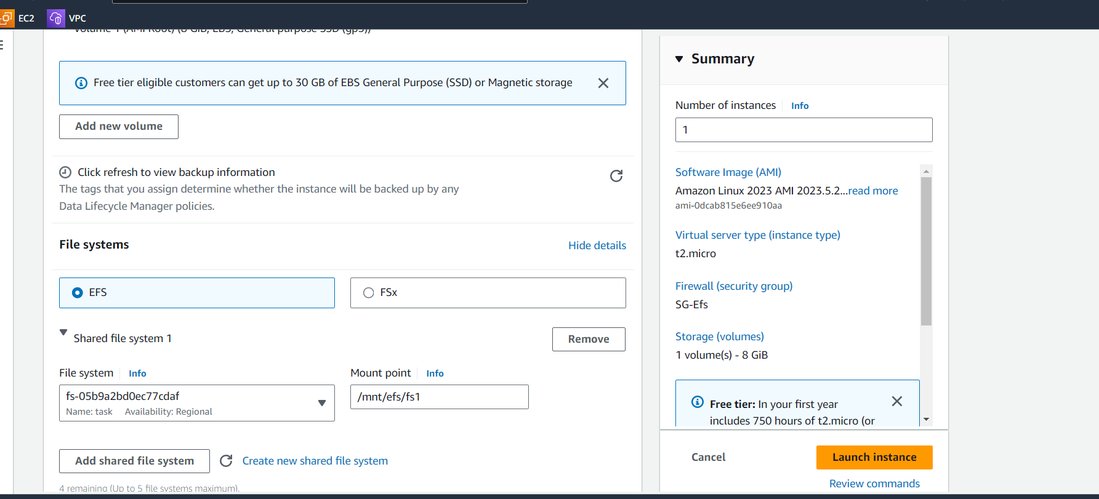

Launch the instance

And connect to the instance

Sudo –i

Cd /mnt/efs/fs1

Created a file with file name as file1

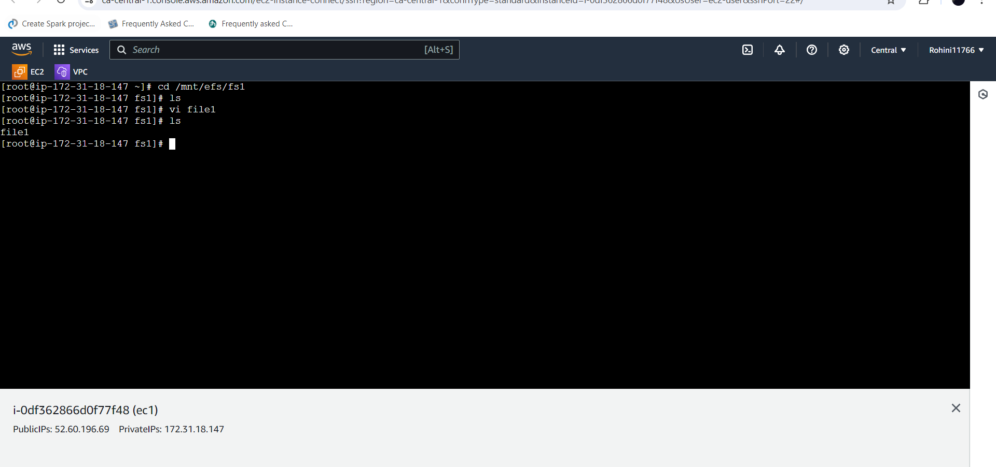

Second instance named as ec2 and selected the subnet as ca-central-1b

And launched the instance.

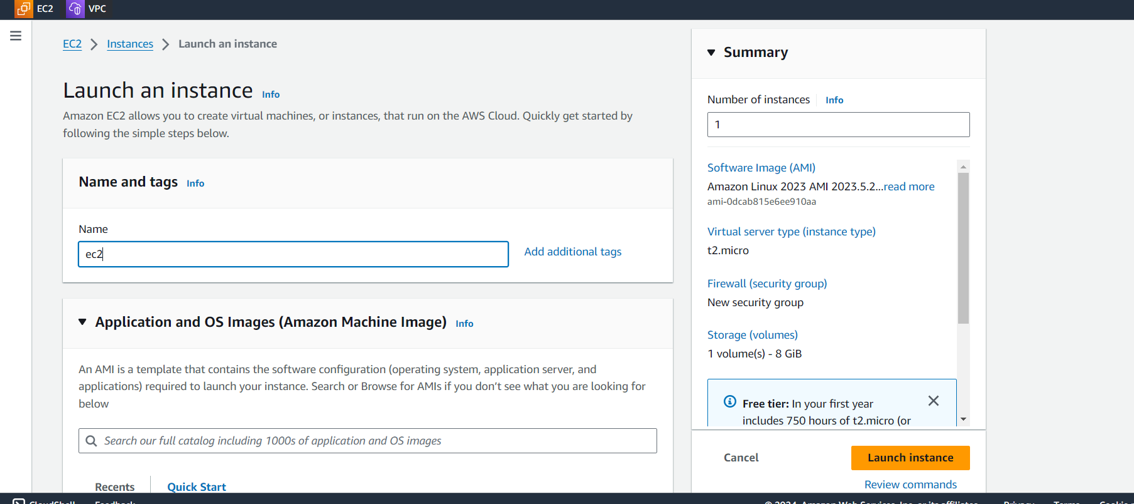

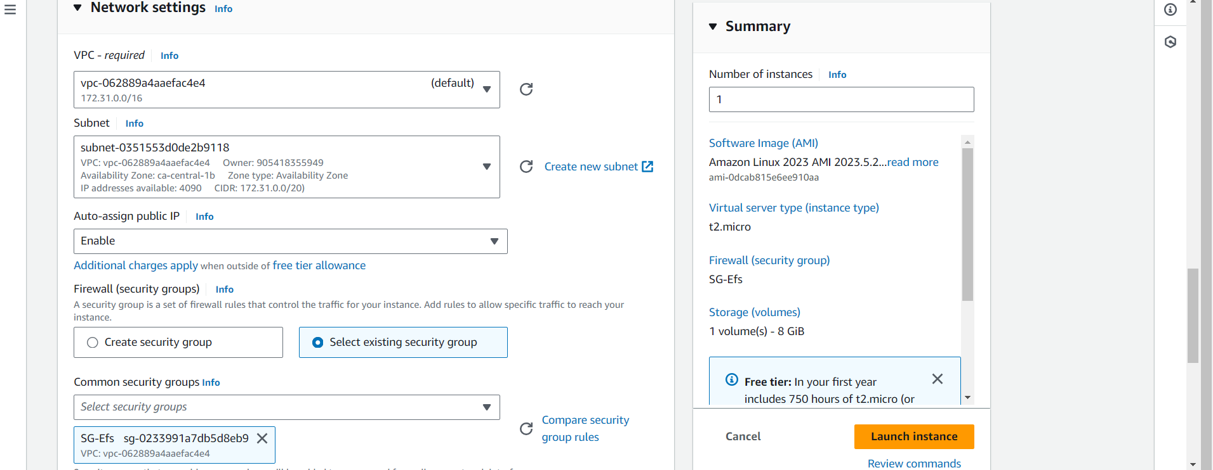

Connected to the instance

Sudo –i

Cd /mnt/efs/fs1

ls

now here we can see the file1 as we created the file in ec1 instance

createda file2 in ec2 instance

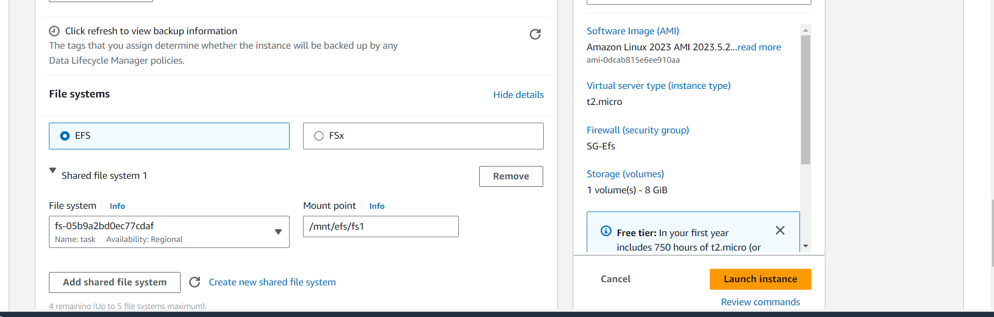

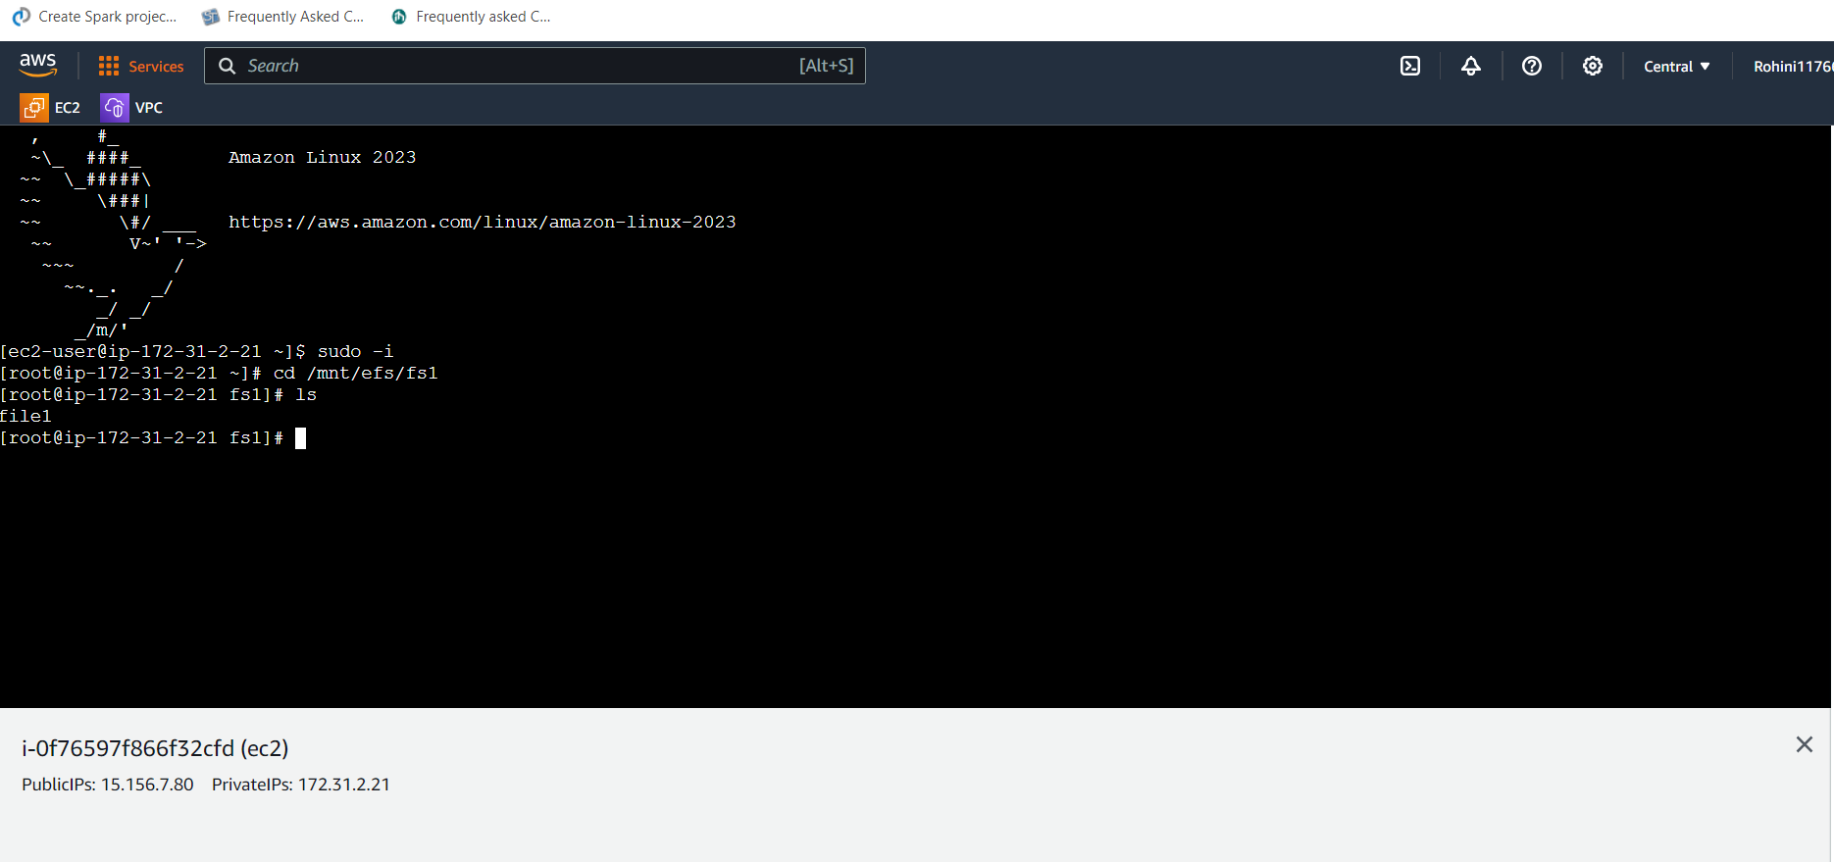

launched the instance ec3 in the zone ca-central-1d and connected to the instance.

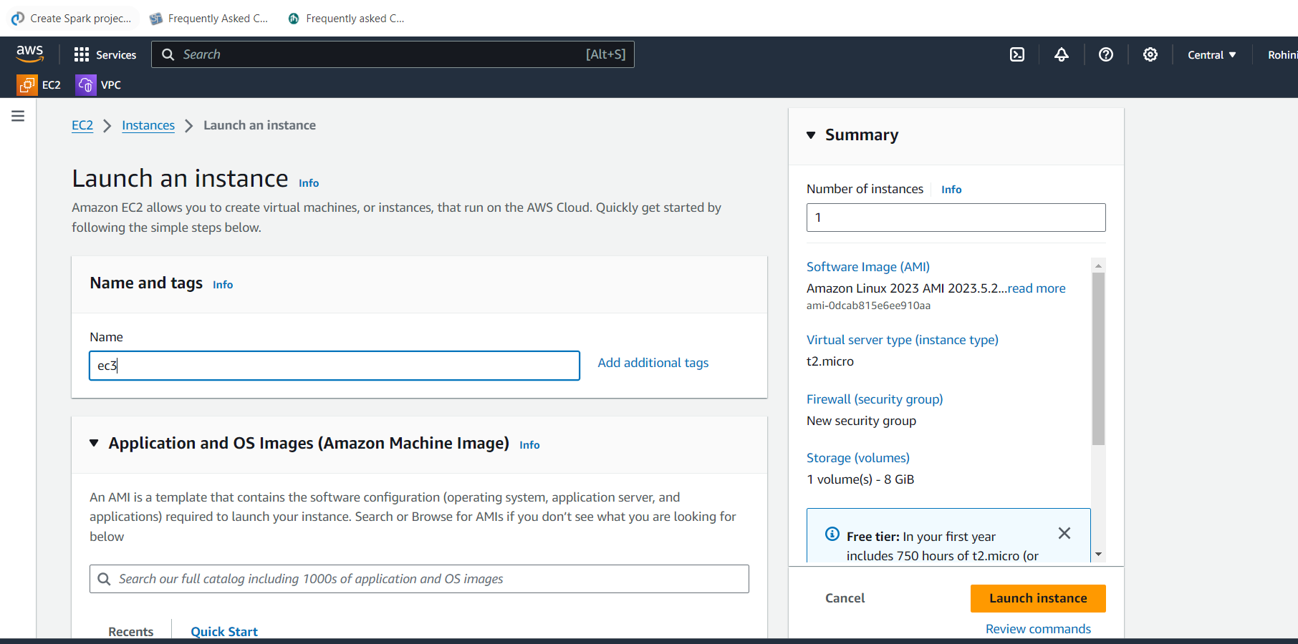

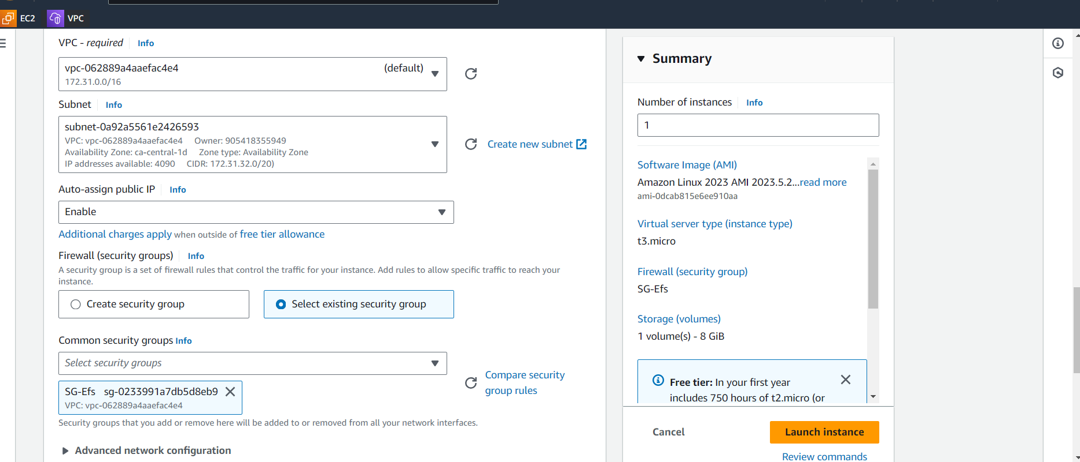

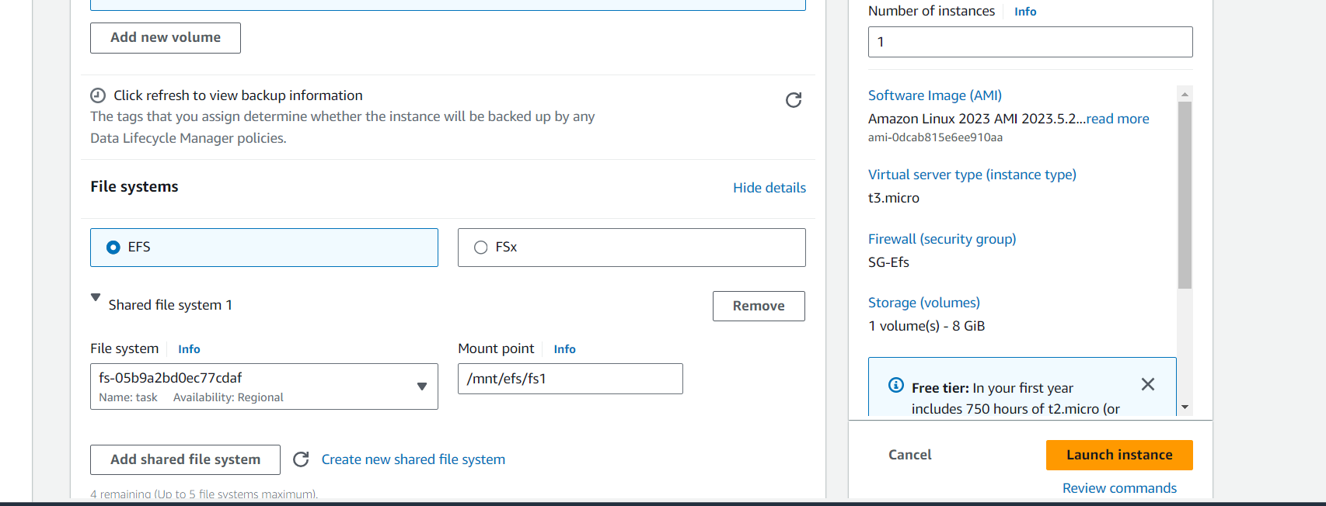

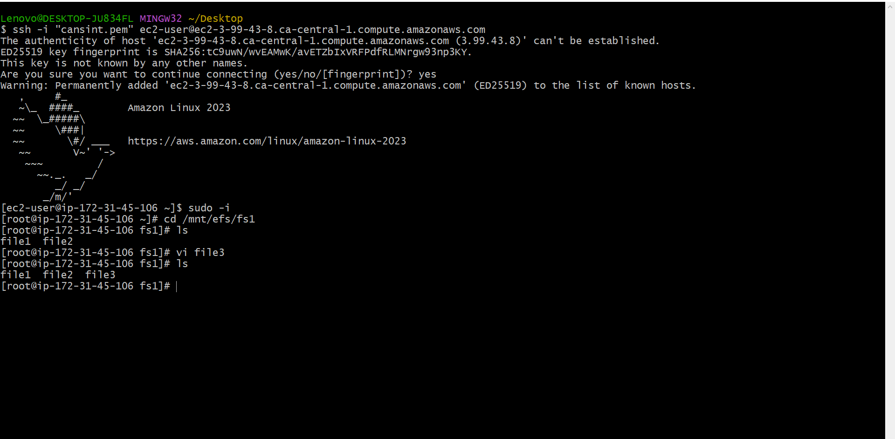

Sudo –i

Cd /mnt/efs/fs1

ls

we can see the file 1 and file 2 in the ec3 instance

now created the file 3 in instance ec3

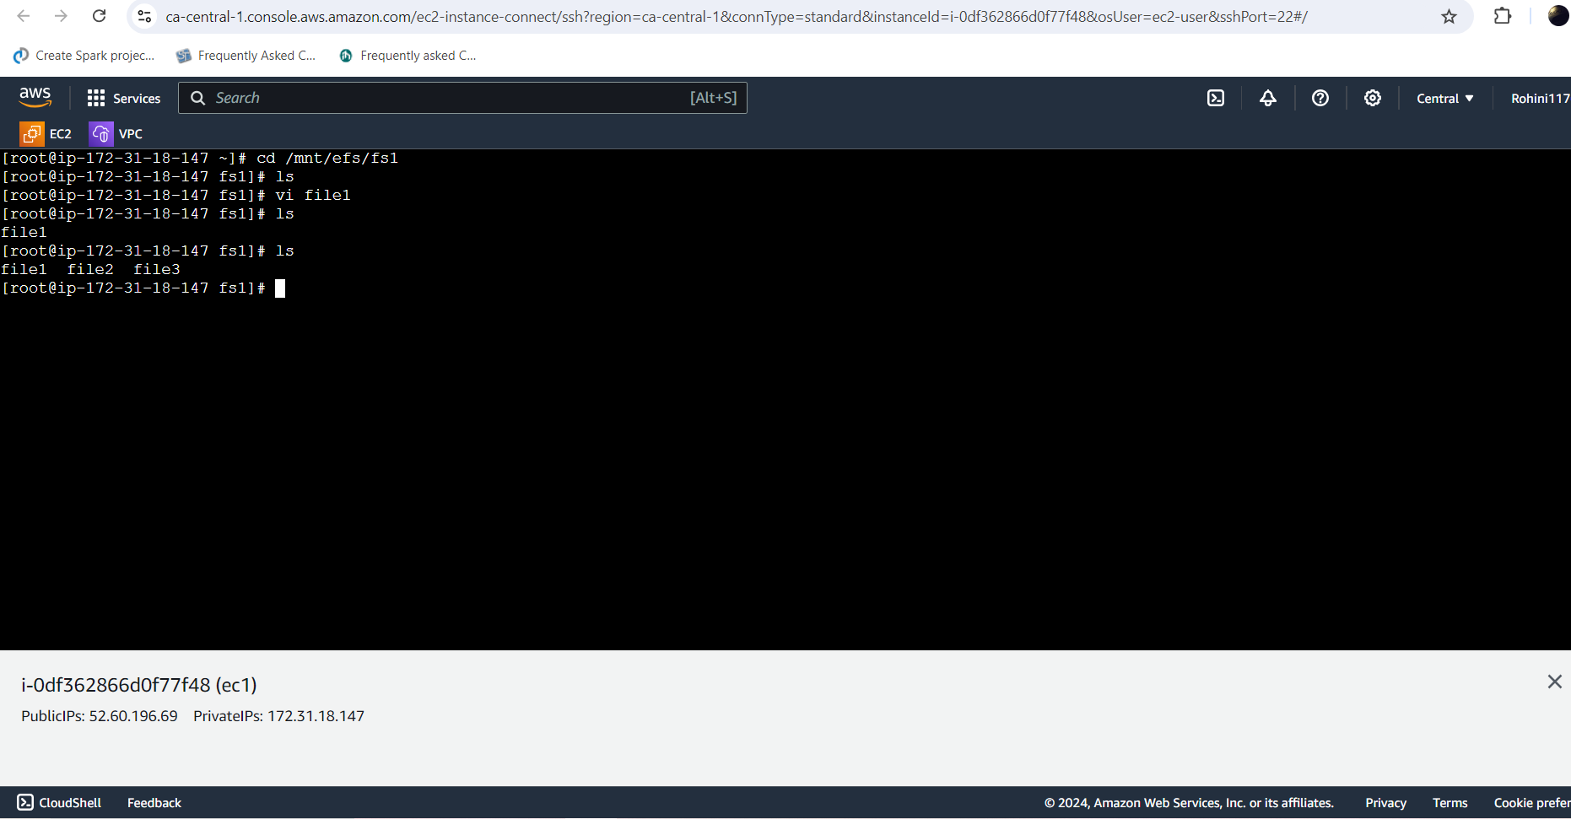

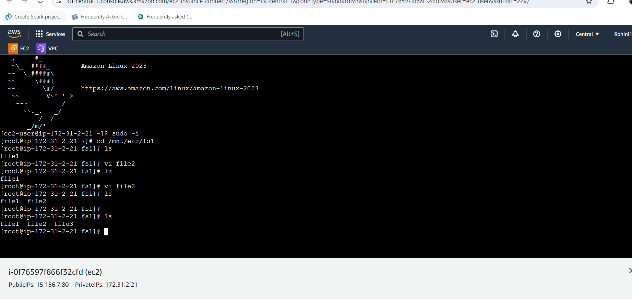

now we can this three files frm any instance (ec1,ec2,ec3)

We can see the file created on this server as well. This proves that our EFS is working.